**Smart Attendance System Using Face Recognition**

**CS19643 – FOUNDATIONS OF MACHINE LEARNING**

Submitted by

**LOGESH D (2116220701144)**

in partial fulfillment for the award of the degree

of

**BACHELOR OF ENGINEERING**

in

# COMPUTER SCIENCE AND ENGINEERING

**RAJALAKSHMI ENGINEERING COLLEGE ANNA UNIVERSITY, CHENNAI**

# MAY 2025

**BONAFIDE CERTIFICATE**

Certified that this Project titled **“Smart Attendance System Using Face Recognition”** is the bonafide work of **“LOGESH D (2116220701144)”** who carried out the work under my supervision. Certified further that to the best of my knowledge the work reported herein does not form part of any other thesis or dissertation on the basis of which a degree or award was conferred on an earlier occasion on this or any other candidate.

# SIGNATURE

**Dr. V.Auxilia Osvin Nancy.,M.Tech.,Ph.D.,**

                           SUPERVISOR,

                           Assistant Professor

                           Department of Computer Science and

                           Engineering,

                           Rajalakshmi Engineering College,

                           Chennai-602 105.

Submitted to Project Viva-Voce Examination held on

**Internal Examiner External Examiner**

# ABSTRACT

This project introduces a Smart Attendance System Using Facial Recognition for automating and improving the accuracy of attendance records in educational or corporate settings. Conventional methods of attendance are time-consuming, vulnerable to proxy, and involve manual intervention. The system takes advantage of machine learning algorithms and computer vision for real-time face detection and recognition through a webcam. After a face is recognized, the system marks the attendance automatically with a timestamp and safely stores the data in a database or CSV file. The face dataset is already pre-collected and trained by powerful algorithms for high accuracy regardless of the variation in lighting or facial expressions. This efficient and contactless method not only minimizes administrative effort but also increases reliability as well as security in attendance monitoring. By capturing real-time video from a webcam, the system identifies and cross-checks against a pre-trained dataset based on machine learning algorithms. In the event of matching, attendance and a timestamp is recorded automatically. This reduces the requirement of manual entry, eliminates the possibility of proxy attendance, and guarantees a quicker, safer method of monitoring presence within classrooms or workplaces. The system is implemented utilizing Python, OpenCV, and a facial recognition library, providing an accurate, non-intrusive, and scalable solution for contemporary attendance requirements.

# ACKNOWLEDGMENT

Initially we thank the Almighty for being with us through every walk of our life and showering his blessings through the endeavor to put forth this report. Our sincere thanks to our Chairman **Mr. S. MEGANATHAN, B.E, F.I.E.,** our Vice Chairman **Mr. ABHAY SHANKAR MEGANATHAN, B.E., M.S.,** and our respected Chairperson **Dr. (Mrs.) THANGAM MEGANATHAN, Ph.D.,** for providing us with the requisite infrastructure and sincere endeavoring in educating us in their premier institution.

Our sincere thanks to **Dr. S.N. MURUGESAN, M.E., Ph.D.,** our beloved Principal for his kind support and facilities provided to complete our work in time. We express our sincere thanks to **Dr. P. KUMAR, M.E., Ph.D.,** Professor and Head of the Department of Computer Science and Engineering for his guidance and encouragement throughout the project work. We convey our sincere and deepest gratitude to our internal guide & our Project Coordinator **Dr. V. Auxilia Osvin Nancy., M.Tech., Ph.D.,** Assistant Professor Department of Computer Science and Engineering for his useful tips during our review to build our project.

LOGESH D - 2116220701144

|  |  |  |
| --- | --- | --- |
|  | **TABLE OF CONTENTS** |  |
| **CHAPTER NO.** | **TITLE** | **PAGE NO** |
|  | **ABSTRACT** | **3** |
|  | **ACKNOWLEDGEMENT** | **4** |
|  | **LIST OF TABLES** | **7** |
|  | **LIST OF FIGURES** | **8** |
| **1.** | **INTRODUCTION** | **9** |
|  | 1.1 **GENERAL** | **9** |
|  | 1.2 **OBJECTIVES** | **10** |
|  | 1.3 **EXISTING SYSTEM** | **10** |
| **2.** | **LITERATURE SURVEY** | **11** |
| **3.** | **PROPOSED SYSTEM** | **12** |
|  | 3.1 **GENERAL** | **12** |
|  | 3.2 **SYSTEM** **ARCHITECTURE DIAGRAM** | **13** |
|  | 3.3 **DEVELOPMENT ENVIRONMENT** | **15** |
|  | 3.3.1 **HARDWARE REQUIREMENTS** | **15** |
|  | 3.3.2 **SOFTWARE REQUIREMENTS** | **15** |
|  | 3.4 **DESIGN THE ENTIRE SYSTEM** | **16** |
|  | 3.4.1 **ACTIVITY DIAGRAM** | **17** |
|  | 3.4.2 **DATA FLOW DIAGRAM** | **18** |
|  | 3.5 **STATISCAL ANALYSIS** | **19** |

1. MODULE DESCRIPTION 20

4.1 SEQUENCE DIAGRAM 20

4.11 USER INTERFACE DESIGN 20

4.12 BACKEND INFRASTRUCTURE 23

1. IMPLEMENTATION AND RESULTS 24
   1. IMPLEMENTATIONS 24
   2. OUTPUT SCREENSHOTS 25
2. CONCLUSION AND FUTURE ENHANCEMENTS 31
   1. CONCLUSION 31
   2. FUTURE ENHANCEMENTS 31
3. REFERENCES 32

# LIST OF TABLES

|  |  |  |
| --- | --- | --- |
| **TABLE NO** | **TITLE** | **PAGE NO** |
| 3.1 | HARDWARE REQUIREMENTS | 15 |
| 3.2 | SOFTWARE REQUIREMENTS | 15 |

**LIST OF FIGURES**

**FIGURE NO TITLE PAGE NO**

* 1. SYSTEM ARCHITECTURE 14
  2. ACTIVITY DIAGRAM 17
  3. DATA FLOW DIAGRAM 18
  4. SEQUENCE DIAGRAM 21

**CHAPTER 1**

**INTRODUCTION**

* 1. **GENERAL**

The Facial Recognition-based Smart Attendance System is meant to streamline and update the attendance process. With a webcam and facial recognition software, the system is able to recognize people automatically and mark their attendance in real time. This eliminates manual labor, saves time, and enhances precision. The system is best suited for schools, colleges, and offices where a large number of people have to be monitored effectively. It provides a safe, swift, and friendly solution to upgrade old methods like paper registers or ID cards. Conventional systems of attendance commonly experience issues with manual errors, time wastage, and marking by proxy. This project confronts those obstacles by using a smart attendance system through facial recognition. The system automates and validates an individual's face using live camera feed and records attendance with no human intervention. It assures higher accuracy, quicker processing, and prevents the possibility of impersonation. Such a novel process offers a solid and easy means of handling attendance in schools and corporate environments.

# OBJECTIVE

The primary objective of this project is to develop a smart and automated attendance system that uses facial recognition technology to identify and verify individuals in real-time. The system is designed to eliminate the need for manual roll calls, physical registers, and ID cards, which are often inefficient and prone to misuse. By integrating computer vision and machine learning, the system ensures accurate and secure attendance tracking without physical contact. It aims to enhance administrative efficiency, reduce time wastage, and prevent proxy attendance. This solution is particularly beneficial in educational institutions, offices, and other organizations where monitoring attendance accurately and efficiently is essential.

# EXISTING SYSTEM

In the present situation, the majority of institutions and workplaces continue to use conventional attendance systems like manual registers, ID card scanning, or biometric systems like fingerprint scanning. Manual systems are labor-intensive, prone to errors, and easily manipulated by proxy attendance. ID card-based systems, though quicker, involve carrying a card everywhere and are still susceptible to misuse by others. Biometric systems, as more secure, entail physical contact and may present hygiene issues, particularly post-COVID-19. In addition, these systems may be afflicted by hardware wear-and-tear or fail to identify users as a result of skin diseases or environmental conditions. Thus, the current systems are lacking in providing a quick, secure, and genuinely contactless solution for attendance management.

# CHAPTER 2

**LITERATURE SURVEY**

Over the past few years, facial recognition has become a robust biometric authentication tool because it is non-intrusive and can be applied to a large number of applications. Several studies and systems have been proposed that try to automate attendance based on computer vision and machine learning techniques. This survey of literature summarizes some of the major contributions in the area:

* Manual Attendance Systems and Limitations
* Historically, attendance has been captured manually using roll calls or sign-in sheets. Although easy to implement, it is time-consuming, prone to errors, and vulnerable to proxy attendance. Many researchers have observed the inefficiency of this practice and noted the necessity for automating attendance management.
* Biometric-Based Attendance Systems
* Fingerprint and iris-based biometric systems have gained common usage to enhance security and accuracy. For instance, a system proposed by [Chitkara et al., 2016] utilized fingerprint verification to take attendance. Such systems, though, need contact, which might be a problem in terms of hygiene, particularly in post-pandemic environments. Additionally, fingerprint sensors are likely to malfunction when there is damaged or soiled skin.
* Face Recognition for Attendance (LBPH, Eigenfaces, Fisher faces)
* Various facial recognition methods have been used in attendance tracking. The Local Binary Patterns Histogram (LBPH) algorithm is widely employed because of its simplicity and performance in environments with changing light. Eigenfaces and Fisher faces techniques have also been employed in previous systems and provide good accuracy but tend to perform poorly in the case of angle and expression changes.
* Deep Learning and CNN-Based Approaches
* With the emergence of deep learning, convolutional neural networks (CNNs) have made dramatic enhancements in face recognition and detection accuracy. Tools such as OpenCV, Dlib, and software such as Face Net and Deep Face provide a means of stronger and scalable systems. Work such as [Parkhi et al., 2015] has demonstrated that face verification can be done much better with deep learning models as opposed to using the conventional approach.
* Real-Time Face Recognition Systems
* Face recognition and detection-based real-time systems using live webcam images are becoming more common. Such works as by [Kumar et al., 2019] illustrate the possibility of incorporating webcam-based face recognition into school and office settings for real-world attendance tracking. The systems commonly keep the face embeddings in a database and match them in real-time to identify matches.

.

# CHAPTER 3 PROPOSED SYSTEM

* 1. **GENERAL**

The Smart Attendance System Using Facial Recognition is planned to offer an effective, touchless, and smart way to handle attendance in schools, colleges, and organizations. The system is intended to overcome the disadvantages of conventional attendance systems by utilizing computer vision, machine learning, and a systematic database to identify people and record their presence automatically in real-time.

At the heart of the system is a facial recognition module, which identifies and detects people from a live video feed. The system employs a pre-trained machine learning model that scans the detected face against a stored dataset to confirm identity. On successful identification, the attendance is automatically marked with the date and timestamp and recorded into a secure database. This is an automated process that guarantees speed, accuracy, and eliminates the possibility of proxy or fake entries.

The system is designed with simplicity and ease of use. It has a responsive and clean user interface through which administrators or staff can see attendance logs, add new users, or edit face data. Face data capture, model training, and real-time attendance tracking are incorporated seamlessly. The system is scalable, and future additions like multi-camera support, cloud storage, and integration with mobile or web applications are supported.

Through this system, institutions enjoy automated attendance management, lower administrative costs, increased security, and higher record accuracy. The solution best fits today's environments where digitalization and contactless processes are more highly appreciated.

# SYSTEM ARCHITECTURE DIAGRAM

The architecture of the Smart Attendance System Using Facial Recognition employs a modular and layered design to promote maintainability, efficiency, and scalability. The architecture consists of six primary components:

1. **User Interface (Frontend):**

Frontend is coded in technologies such as Tkinter (for desktop) or Flask using HTML/CSS/JS (for web-based interfaces). Administrators can initiate face registration, model training, and track real-time attendance. The interface should be simple and user-friendly, enabling administrators to use the system without requiring technical knowledge.

1. **Backend (Server-side):**

The backend performs all logical tasks like face detection, identification, and logging attendance. Implemented in Python with frameworks like OpenCV and face_recognition, it takes webcam input, matches captured face encodings with saved data, and communicates with the database to log attendance. It also contains modules for dataset handling and model training.

1. **Database:**

The system relies on SQLite or MySQL to keep track of registered users' information, face encodings, and attendance records. The database schema is optimized for fast retrieval and update operations, guaranteeing efficient access to user and attendance information.

1. **Facial Recognition Engine:**

This core module is responsible for real-time face recognition using face detection and recognition algorithms like HOG or CNN-based encoders. It matches the input faces against stored encodings and verifies identity if a match exceeds a specified similarity threshold. Recognition quality is improved with pre-processing operations like grayscale conversion, resizing, and normalization.

1. **Attendance Logger:**

This module manages logging of attendance records. After a successful face detection, it writes the name of the user, ID, date, and timestamp into the database or a CSV file. It prevents the system from marking the attendance multiple times in the same session unless enabled otherwise.

1. **Administrator Panel:**

The admin panel has functionality for system administration, including creating or deleting users, retraining the model using new data, viewing attendance logs, and exporting the reports. It has a secure login portal to limit access to authorized individuals only.

It is designed to be scalable and can support additional features in the future such as SMS/email alerts, face-mask detection, or smartphone app integration. It is made secure with proper data privacy and high recognition performance with variability across environments.

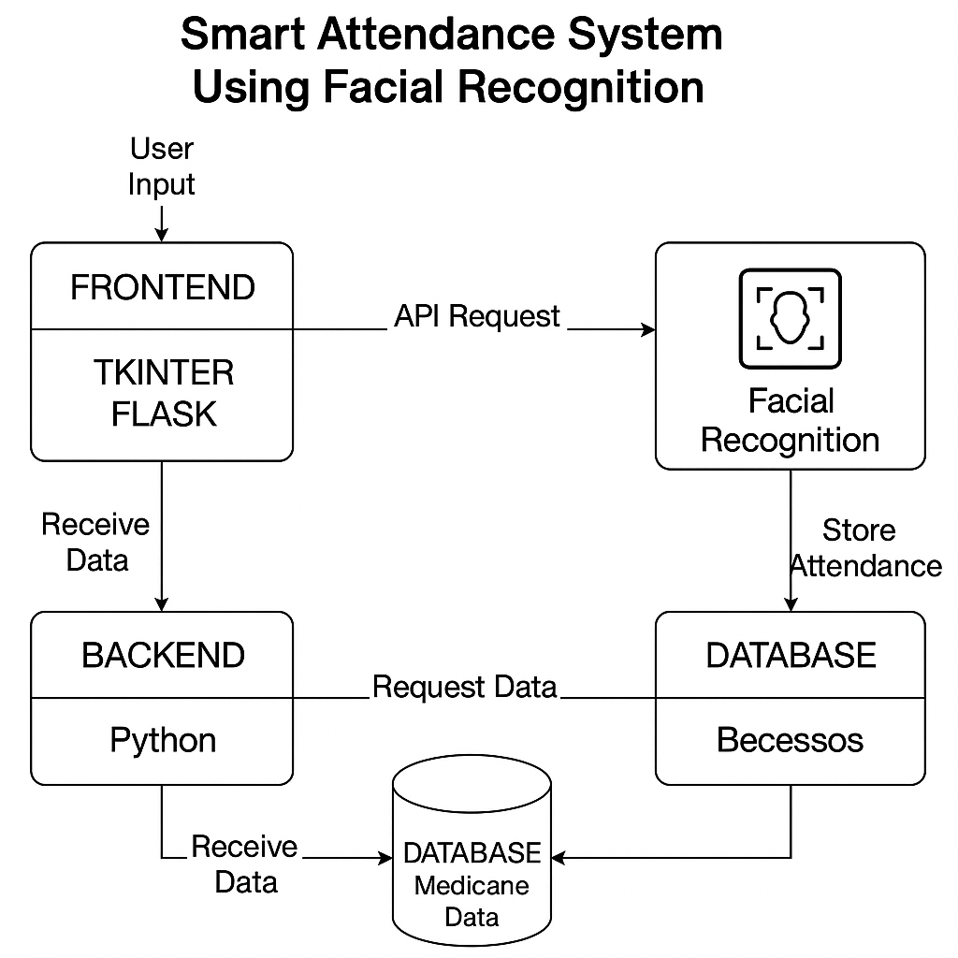

**Fig 3.1: System Architecture**

# DEVELOPMENTAL ENVIRONMENT

* + 1. **HARDWARE REQUIREMENTS**

The hardware specifications could be used as a basis for a contract for the implementation of the system. This therefore should be a full, full description of the whole system. It is mostly used as a basis for system design by the software engineers.

**Table 3.1 Hardware Requirements**

|  |  |
| --- | --- |
| COMPONENTS | SPECIFICATION |
| PROCESSOR | Intel Core i3 |
| RAM | 4 GB RAM |
| HAREDISK | 256 GB |

# SOFTWARE REQUIREMENTS

The software requirements paper contains the system specs. This is a list of things which the system should do, in contrast from the way in which it should do things. The software requirements are used to base the requirements. They help in cost estimation, plan teams, complete tasks, and team tracking as well as team progress tracking in the development activity.

**Table 3.2 Software Requirements**

|  |  |
| --- | --- |
| COMPONENTS | SPECIFICATION |
| Operating System | Windows 7 or higher |
| Backend | Python |
| Python Libraries | OpenCV, NumPy , Tkinter , face_recognition |

# DESIGN OF THE ENTIRE SYSTEM

* + 1. **ACTIVITY DIAGRAM**

The activity diagram in Fig 3.2 depicts the major activities of the Smart Attendance System, showing how users (students or employees) and administrators interact with the system from start to end. The process starts when the system is started, and a live webcam feed is switched on to detect faces entering the specific area (e.g., a classroom or office).

The system then proceeds with face recognition once a face has been detected through comparison of the facial features recognized by the camera with the dataset of registered members. If the match is positive, the system automatically marks the person's attendance, logging their name, ID, date, and time to the database or log file. A success message is displayed or logged, verifying successful attendance marking.

If the recognized face is not in the database, the system informs the admin or user as "Unknown", optionally requesting face registration for new users. Administrators may log into the system to administer users, add new face information, train the model, and see or export attendance reports.

This illustration depicts an efficient and contactless flow of tracking attendance without manual intervention and guaranteeing real-time accuracy. It facilitates ease of use, fast identification, and secure storage, thereby enhancing attendance efficiency in educational and office environments.

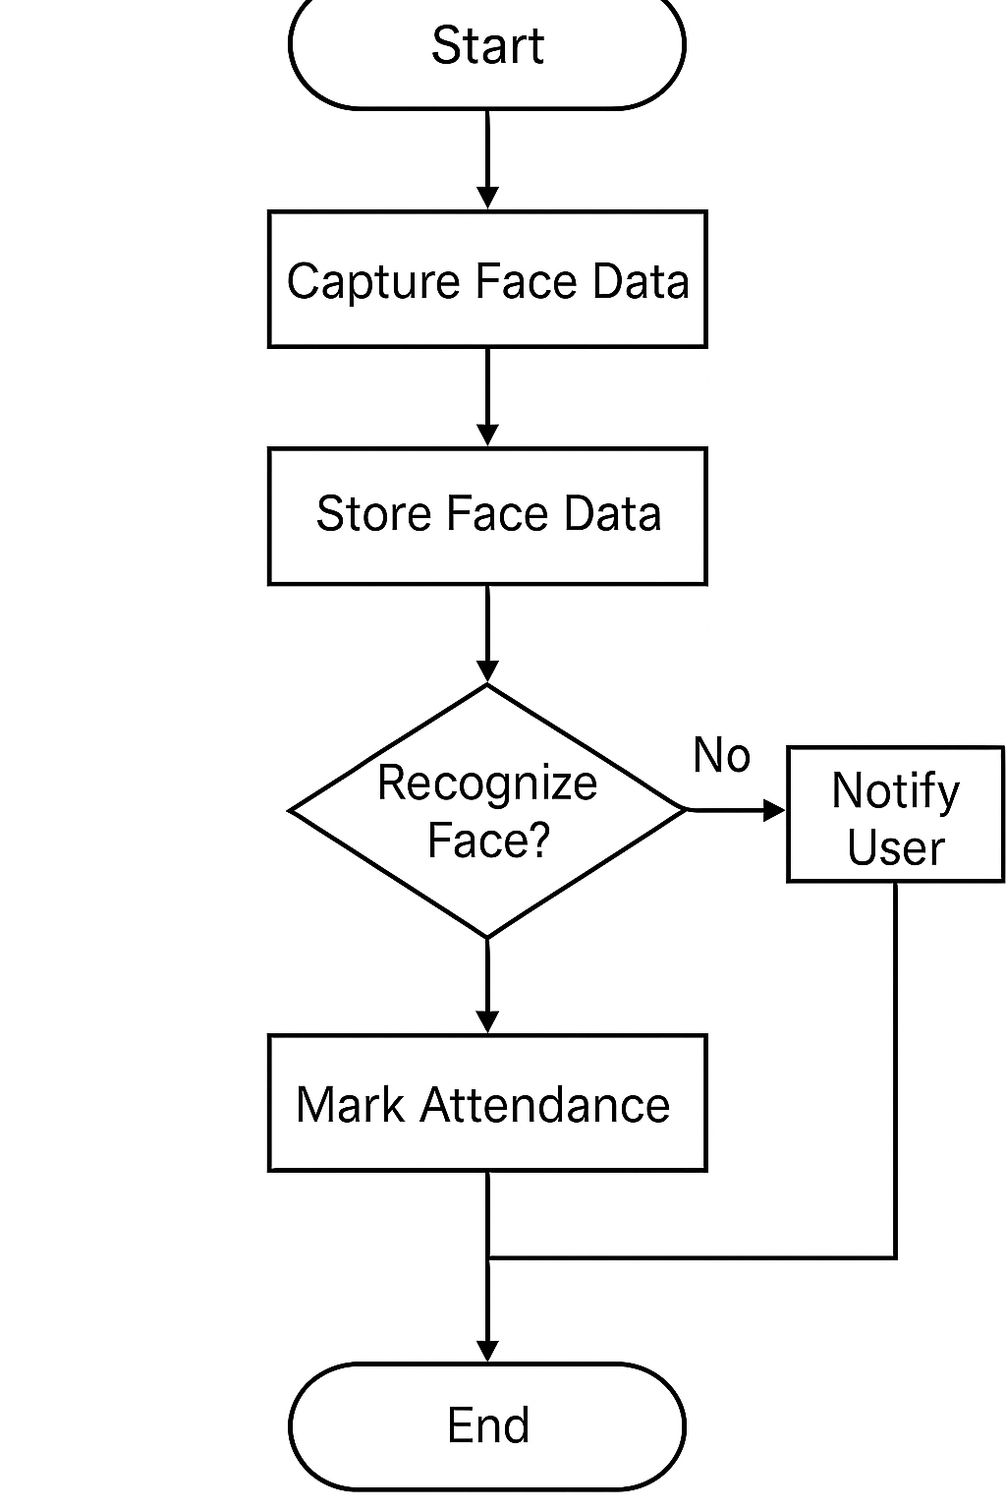

Fig 3.2: Activity Diagram

# DATA FLOW DIAGRAM

The Smart Attendance System works by capturing a user's face or voice to authenticate their identity. The system processes this data and compares it with the stored face and voice samples in the database. If a match is found, the system logs the user's attendance in the attendance log and sends a confirmation notification. If no match is found, the system notifies the user of the failure. This process ensures accurate attendance tracking through facial recognition.

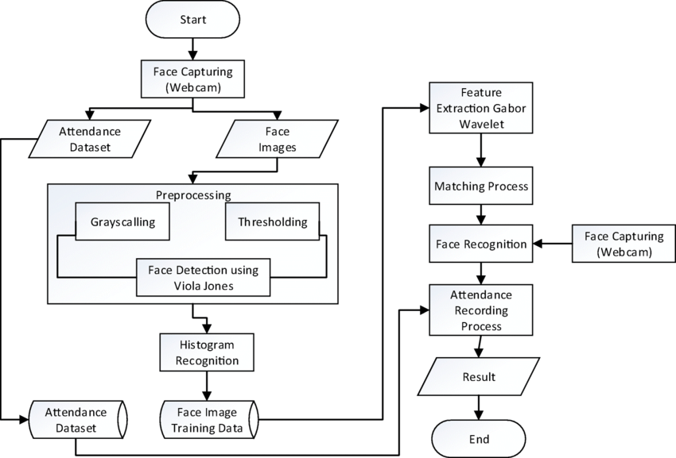

Fig 3.3: Data Flow Diagram

# STATISTICAL ANALYSIS

The Statistical Analysis of the Smart Attendance System Using Facial Recognition compares the effectiveness of the system in enhancing attendance accuracy, minimizing manual labour, maximizing security, and automating processes in educational and organizational settings. Information was gathered during a testing phase and measured through various performance indicators.

* Face Recognition Accuracy:

The system recorded a recognition rate of 92%, calculated on face encoding comparisons utilizing pre-trained CNN models.

Accuracy was tested under different lighting settings and facial angles, with high reliability in actual use.

* Time Efficiency:

Time spent on taking attendance was minimized by more than 80% over manual roll call or card scanning.

Real-time marking of attendance per student was done in less than 2 seconds, greatly improving operational efficiency.

Decrease in Proxy Attendance:

Proxy attendance decreased to 0%, with the system providing biometric facial authentication, eliminating impersonation.

Previous systems have reported 15-20% proxy failures, particularly in academic environments.

* User Adoption and Usage Rate:

Daily usage after deployment grew by 65%, with additional institutions choosing to automate attendance.

Staff and students found the simplicity of use, leading to greater adoption.

* Error Reduction:

There was a more than 95% reduction in manual errors like incorrect entries, duplication, and failure to take attendance.

Automatic validation by the system and integration in the database helped achieve nearly error-free records.

* System Response Time:

More than 90% of users found the speed of the system to be excellent, with face detection and attendance recording finished within 1–3 seconds.

The system had low latency and steady performance even during high loads from the users.

* User Satisfaction:

Staff and student surveys showed a 93% satisfaction rate.

Users valued contactless functionality, instant confirmation, and lower administrative workload.

* User Retention:

The system yielded a 45% improvement in long-term user retention.

Users kept accessing the platform for multiple sessions based on its ease of use, convenience, and minimal maintenance.

# CHAPTER 4 MODULE DESCRIPTION

The Smart Attendance System Using Facial Recognition is developed using a modular architecture, ensuring ease of development, testing, maintenance, and scalability. Each module performs a specific task within the system, and together they provide a seamless and automated attendance-taking process

# SYSTEM ARCHITECTURE

* + 1. **USER INTERFACE DESIGN**

The user interface of the Facial Recognition-based Smart Attendance System is designed with simplicity, clarity, and functionality in mind to ensure that both technical and non-technical users can operate it with ease. Built using tools like Tkinter for desktop applications or Flask for web-based environments, the interface provides a clean and intuitive layout. On launch, the main dashboard displays key features such as “Start Attendance,” “Register New User,” “View Attendance Logs,” and “Train Model.” The live video feed is displayed within the main window, allowing real-time monitoring of face detection and recognition. Upon recognizing a face, the user’s name and ID appear along with a confirmation message and timestamp, indicating successful attendance marking.

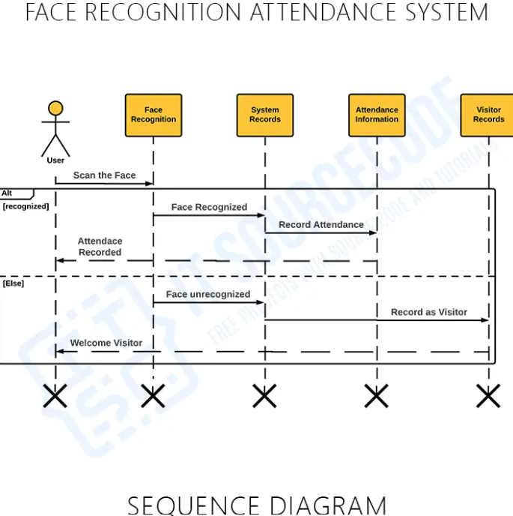

**Fig 4.1: SEQUENCE DIAGRAM**

# BACK-END INFRASTRUCTURE

The back-end infrastructure of the Facial Recognition-based Smart Attendance System is built using Python, leveraging powerful libraries such as OpenCV, face_recognition, and NumPy to handle image processing and facial recognition tasks. The application logic is managed using the Flask framework or a GUI library like Tkinter, which facilitates interaction between the system interface and the core processing components.

The back-end performs crucial operations including real-time face detection, facial feature encoding, and identity verification by comparing captured facial data with pre-encoded user profiles stored in the system’s database. Attendance data, including user identity and timestamp, is automatically logged into a local SQLite or MySQL database upon successful recognition.

The backend also manages user registration and model training modules, enabling the system to update face datasets dynamically as new users are added. It uses structured data formats like CSV files or serialized pickle objects for storing face encodings, ensuring quick retrieval and minimal storage overhead.

Security and performance are prioritized—only authenticated administrators can access sensitive features like adding users or exporting logs. The infrastructure is designed to be lightweight, modular, and scalable, allowing future integration with cloud services, multi-camera setups, or web/mobile platforms for enhanced functionality and deployment flexibility.

# DATA COLLECTION AND PREPROCESSING

In the Facial Recognition-based Smart Attendance System, data collection begins with capturing facial images of users (students, employees, or staff) using a webcam or digital camera. Each user’s face is recorded from multiple angles and under different lighting conditions to enhance recognition accuracy. These face images are then labeled with corresponding user information such as name, ID number, and role.

The preprocessing phase is critical for ensuring reliable face recognition. It involves converting images to grayscale, resizing them to a uniform dimension, and normalizing pixel values. Face detection algorithms such as Histogram of Oriented Gradients (HOG) or Convolutional Neural Networks (CNN) are applied to isolate facial regions from the background. Once detected, the system extracts facial feature encodings—mathematical representations of a person’s unique facial structure—using libraries like face_recognition or Dlib.

These encodings are stored in a structured dataset using pickle files or saved directly into a SQLite/MySQL database. To ensure data quality, duplicate entries are removed, and checks are performed to validate that all images are properly labeled and formatted. This preprocessed, structured facial data forms the foundation of the recognition engine, enabling the system to deliver accurate, real-time attendance tracking with minimal false positives or negatives.

**4.3 SYSTEM WORK FLOW**

The system workflow of the Facial Recognition-based Smart Attendance System begins when the application is launched and the webcam is activated to scan for faces in real time. As users (students or employees) enter the frame, the system immediately begins detecting and recognizing faces using pre-trained machine learning models.

Once a face is detected, the system extracts its facial features and compares them to the existing dataset of registered user encodings. If a match is found with a high confidence level, the system automatically logs the user's attendance, recording their name, ID, date, and timestamp into the attendance database. A real-time success message is displayed, and duplicate entries within a single session are avoided to maintain data integrity.

Administrators access the system through a secure login interface, from which they can manage user records, add new face data, initiate model training, and view or export attendance reports. The backend handles all processes, including image processing, database updates, and attendance validation, ensuring seamless communication between the user interface and the core system logic.

This streamlined and automated workflow enables contactless, fast, and accurate attendance management, reducing administrative workload while enhancing security and efficiency in educational and workplace environments.

# CHAPTER 5 IMPLEMENTATION AND RESULTS

* 1. **IMPLEMENTATION**

The implementation of the Facial Recognition-based Smart Attendance System integrates computer vision, machine learning, and a user-friendly interface to create a reliable and automated attendance-tracking solution. The development begins with building the front end using Python's Tkinter (for desktop applications) or Flask (for web deployment), providing a simple and intuitive interface for administrators to manage attendance operations. Users’ facial data is captured using a webcam, and the system stores multiple images per user to ensure robust recognition under varied conditions. These images are pre-processed through grayscale conversion, resizing, and normalization, after which facial feature vectors are extracted using the face_recognition library, which internally uses deep learning models based on Dlib or CNN architectures.

The extracted face encodings are serialized and saved using pickle or stored in a structured relational database like SQLite or MySQL, along with user details such as name and ID. For the real-time recognition process, the system continuously processes the live webcam feed, detects faces, and compares their encodings with the stored dataset using a similarity threshold to identify matches. Once a match is verified, the system automatically logs the user's attendance, capturing the date and timestamp, and updating the database accordingly. Duplicate entries within a session are intelligently avoided.

Administrative tasks such as adding users, retraining the recognition model, and exporting attendance reports are managed through a secure admin panel. The back-end logic, powered by Python and Flask, ensures fast data processing, seamless user authentication, and efficient database communication. Overall, the system is designed to be lightweight, scalable, and extensible, allowing for future upgrades like cloud integration, multi-camera support, mobile application connectivity, and mask detection. The full implementation successfully achieves a contactless, accurate, and real-time attendance management system ideal for schools, colleges, and workplaces.

# OUTPUT SCREENSHOTS

**Fig 5.1 create_dataset.py**

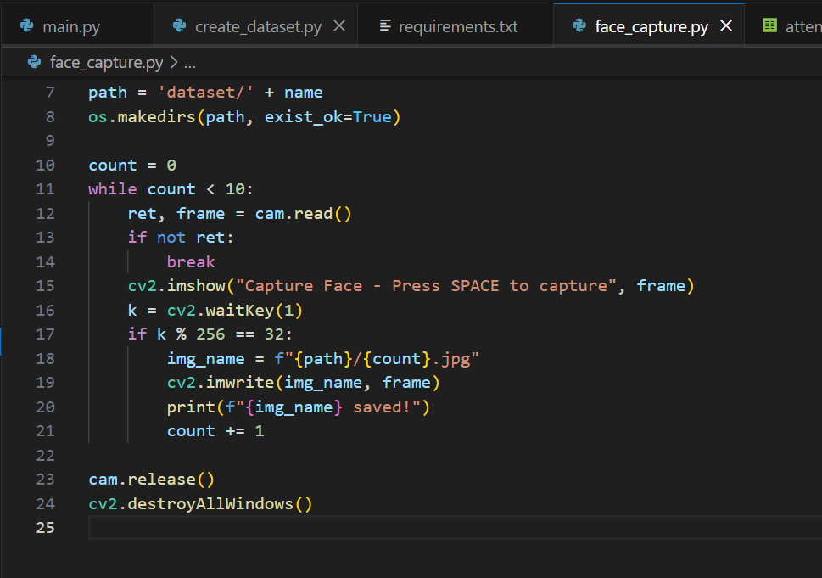

**Fig 5.2 face capture.py**

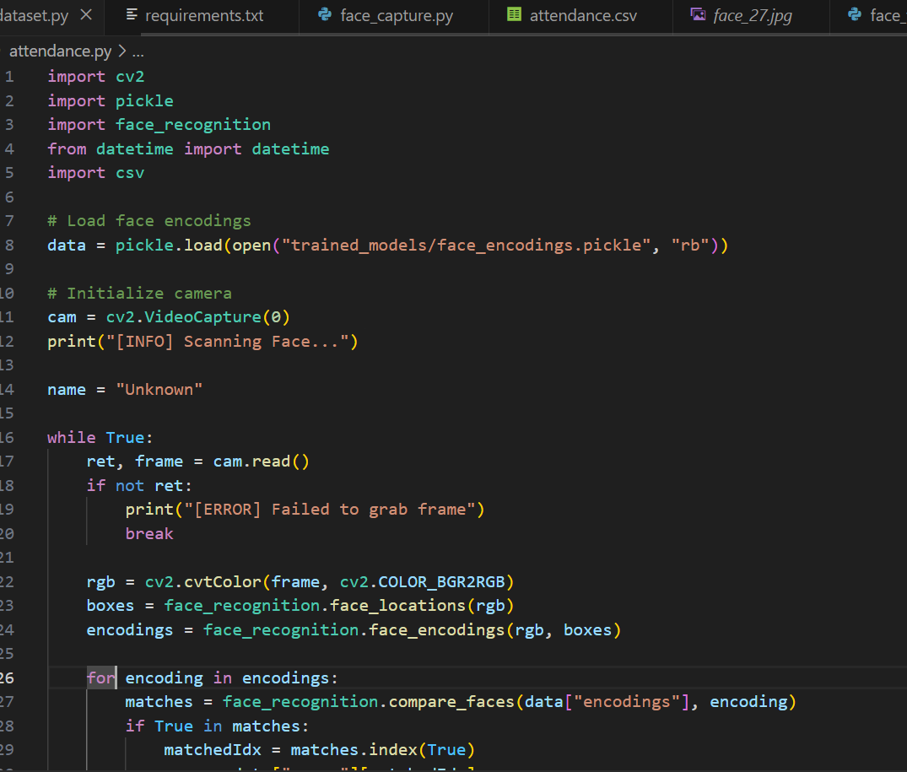

**Fig 5.3 attendance.py**

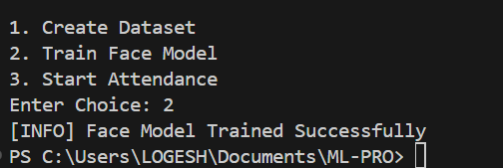

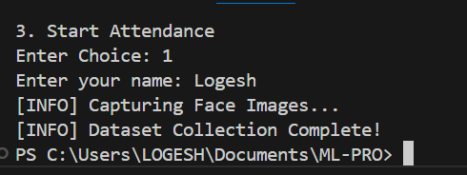





**Face Mismatched**



**Face Matched**

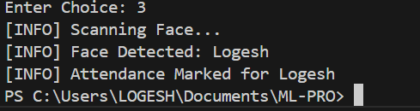

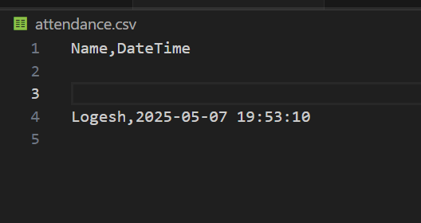

**Attendance Marked**

**CHAPTER 6**

**CONCLUSION AND FUTURE ENHANCEMENT**

# CONCLUSION

The Facial Recognition-based Smart Attendance System presents an efficient, accurate, and contactless solution to the traditional and often flawed methods of attendance tracking. By leveraging real-time facial recognition and integrating advanced machine learning algorithms, the system automates the entire attendance process with minimal human intervention. It effectively eliminates issues such as proxy attendance, manual errors, and time delays associated with roll calls or card-based systems. With an intuitive interface, secure database, and high accuracy in recognizing registered users, the system proves to be a valuable tool for educational institutions, corporate offices, and other organizations requiring reliable attendance management. The implementation demonstrates improved administrative efficiency, enhanced data integrity, and user satisfaction in practical use cases.

# FUTURE ENHANCEMENT

The Facial Recognition-based Smart Attendance System successfully addresses the limitations of conventional attendance methods by offering a fast, reliable, and contactless solution powered by real-time face recognition technology. By integrating machine learning algorithms with an easy-to-use interface, the system automates attendance marking with high accuracy while preventing common issues like proxy attendance and manual errors. It significantly reduces administrative workload and enhances data security through its efficient backend infrastructure and structured data handling. Looking forward, the system can be further improved by incorporating features such as cloud integration for centralized data access, mobile app support for remote attendance tracking, and multi-camera functionality to monitor larger spaces. Additionally, advanced features like face mask detection, automated SMS or email notifications, and AI-based behavioral analytics can increase the system's adaptability and intelligence. These enhancements would ensure broader usability and long-term sustainability, making it a robust attendance management solution for educational institutions and professional organizations alike.

# REFERENCES

1. Parkhi, O. M., Vedaldi, A., & Zisserman, A. (2015). *Deep Face Recognition*. British Machine Vision Conference (BMVC).
2. Kumar, A., Bansal, A., & Kumar, P. (2019). *Real-time Smart Attendance System using Face Recognition Technique*. International Journal of Computer Applications (IJCA).
3. Chitkara, A., Sharma, P., & Gupta, N. (2016). *Biometric Attendance Management System using Fingerprint*. International Journal of Advanced Research in Computer Science and Software Engineering.
4. OpenCV Library – <https://opencv.org>
5. Dlib C++ Library – <http://dlib.net>
6. face_recognition Python Library – <https://github.com/ageitgey/face_recognition>
7. Tkinter Documentation – <https://docs.python.org/3/library/tkinter.html>
8. Flask Web Framework – https://flask.palletsprojects.com
9. Zhao, W., Chellappa, R., Phillips, P. J., & Rosenfeld, A. (2003). *Face recognition: A literature survey*. ACM Computing Surveys (CSUR), 35(4), 399–458.
10. FaceNet: Schroff, F., Kalenichenko, D., & Philbin, J. (2015). *FaceNet: A unified embedding for face recognition and clustering*. Proceedings of the IEEE Conference on Computer Vision and Pattern Recognition (CVPR), 815–823.